Contact Number: +971585218081 at Delivery banner

Banner Images Text

White Butter Text: **Pure & Fresh White Butter Now Available in UAE**

Paneer Text: **Real Indian Fresh & Soft Malayi Paneer Now Available in UAE**

Milk Image Text: **100% Real Fresh Dairy Milk**

Mom Made pickles & Chutneys image needs to be added

Text under Shop by Category

Check out our collection inspired by desi-ism.

Featured Products

Check out our collection of Top picks.

Remove “Tailored for your growing baby” section and add “Daily Deals”

Remove “Our featured in” Text and make it “They Love talking about Us”

Logos of the magazines emailed

Customer Testimonials

Images

We Like You. Too!

Subscribe to newsletter Text: Get the latest updates on our new products  
and upcoming promotions.

Desidukaan.ae Text: From sourcing delicious high quality products to delivering them FRESH, Free & on time right to your doorstep!

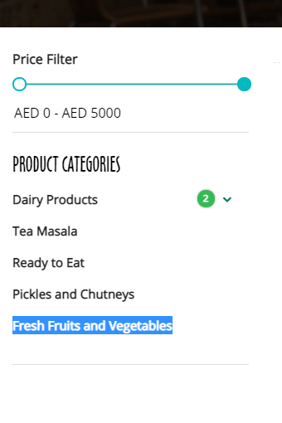

All the categories should be shown together

Prices to be in AED

.

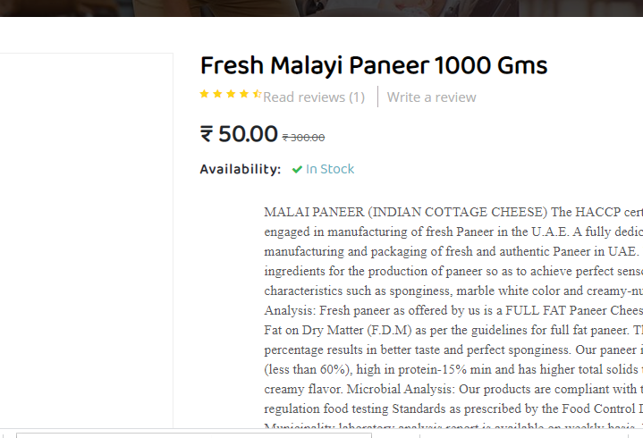

Prices are not matching with the prices put in the CRM Admin Portal.

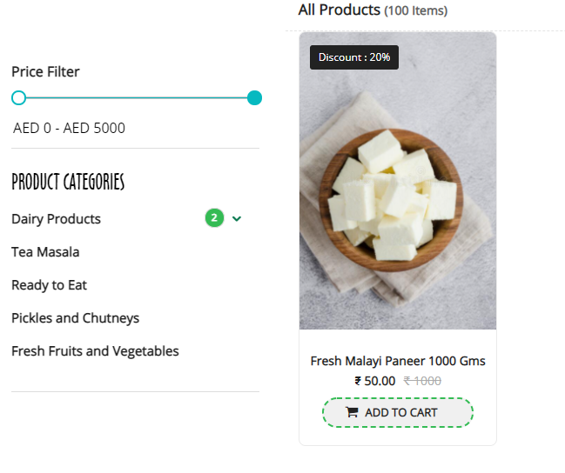

Country of Origin required under the name of the product along with the prices.

Price filter needs to be corrected. Max range should be calculated automatically, if not possible, limit can be set thru admin portal. (We set 50 values ​​to the maximum limit because we can't do it dynamically)

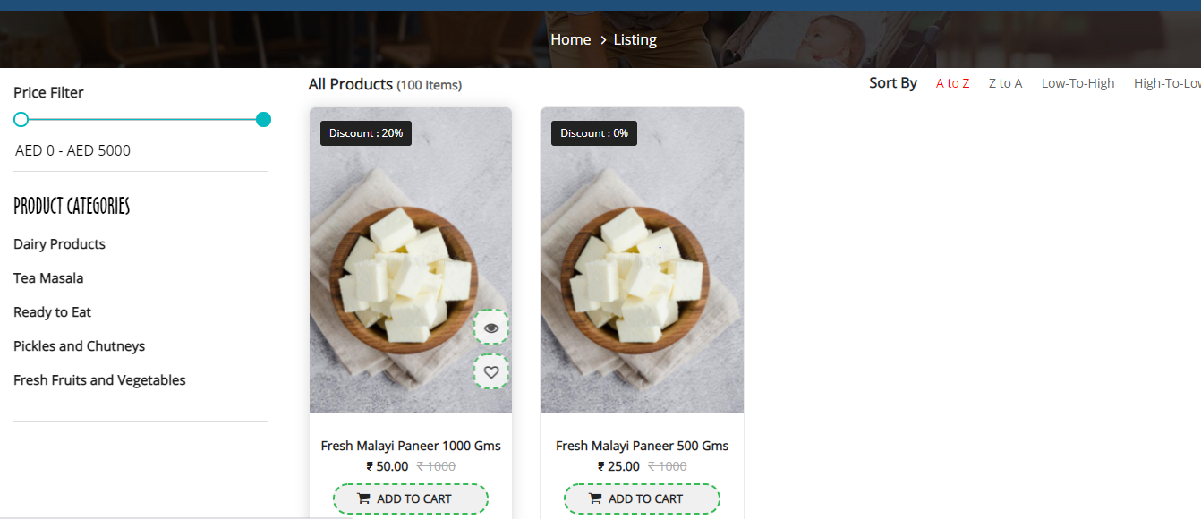

This black color should be some other color and on the right side you need to write “Where desi meets healthy” in the font.

And on the left side we want to show the value of their cart and how much its left to get free delivery.